**SQL Assignment –1**

**Northwind database**

**Link:**

https://github.com/microsoft/sql-server-samples/blob/master/samples/databases/northwind-pubs/instnwnd.sql

**Sample table :Products**

-ProductID

-ProductName

-SupplierID

-CategoryID

-QuantityPerUnit

-UnitPrice

-UnitsInStock

-UnitsOnOrder

-ReorderLevel

-Discontinued

**1) Write a query to get a Product list (id, name, unit price) where current products cost less than $20.**

**Code:**

select ProductID, ProductName, UnitPrice FROM Products where UnitPrice<20 and Discontinued=0;

**Output:**

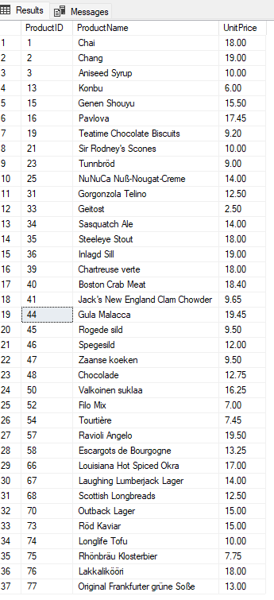

**2) Write a query to get Product list (id, name, unit price) where products cost between $15 and $25.**

**Code:**

select ProductID, ProductName, UnitPrice FROM Products where UnitPrice>15 and UnitPrice<25;

**Output:**

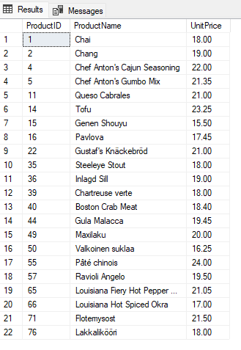

**3) Write a query to get Product list (name, unit price) of above average price.**

**Code:**

select ProductName, UnitPrice FROM Products where UnitPrice>(select AVG(UnitPrice) from products);

**Output:**

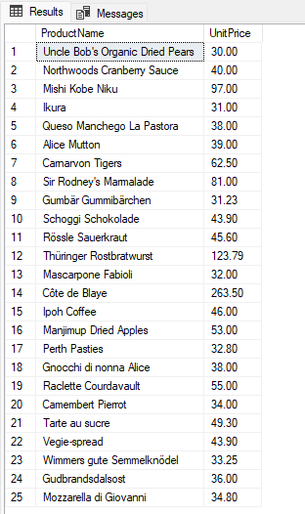

**4) Write a query to get Product list (name, unit price) of ten most expensive products.**

**Code:**

SELECT TOP 10 ProductName, UnitPrice from Products order by UnitPrice DESC;

**Output:**

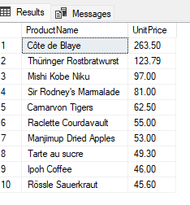

**5) Write a query to count current and discontinued products.**

**Code:**

select discontinued, count(discontinued) from products group by discontinued;

**Output:**

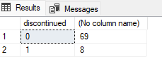

**6) Write a query to get Product list (name, units on order , units in stock) of stock is less than the quantity on order.**

**Code:**

select ProductName, UnitsInStock, UnitsOnOrder from products where UnitsOnOrder>UnitsInStock;

**Output:**

